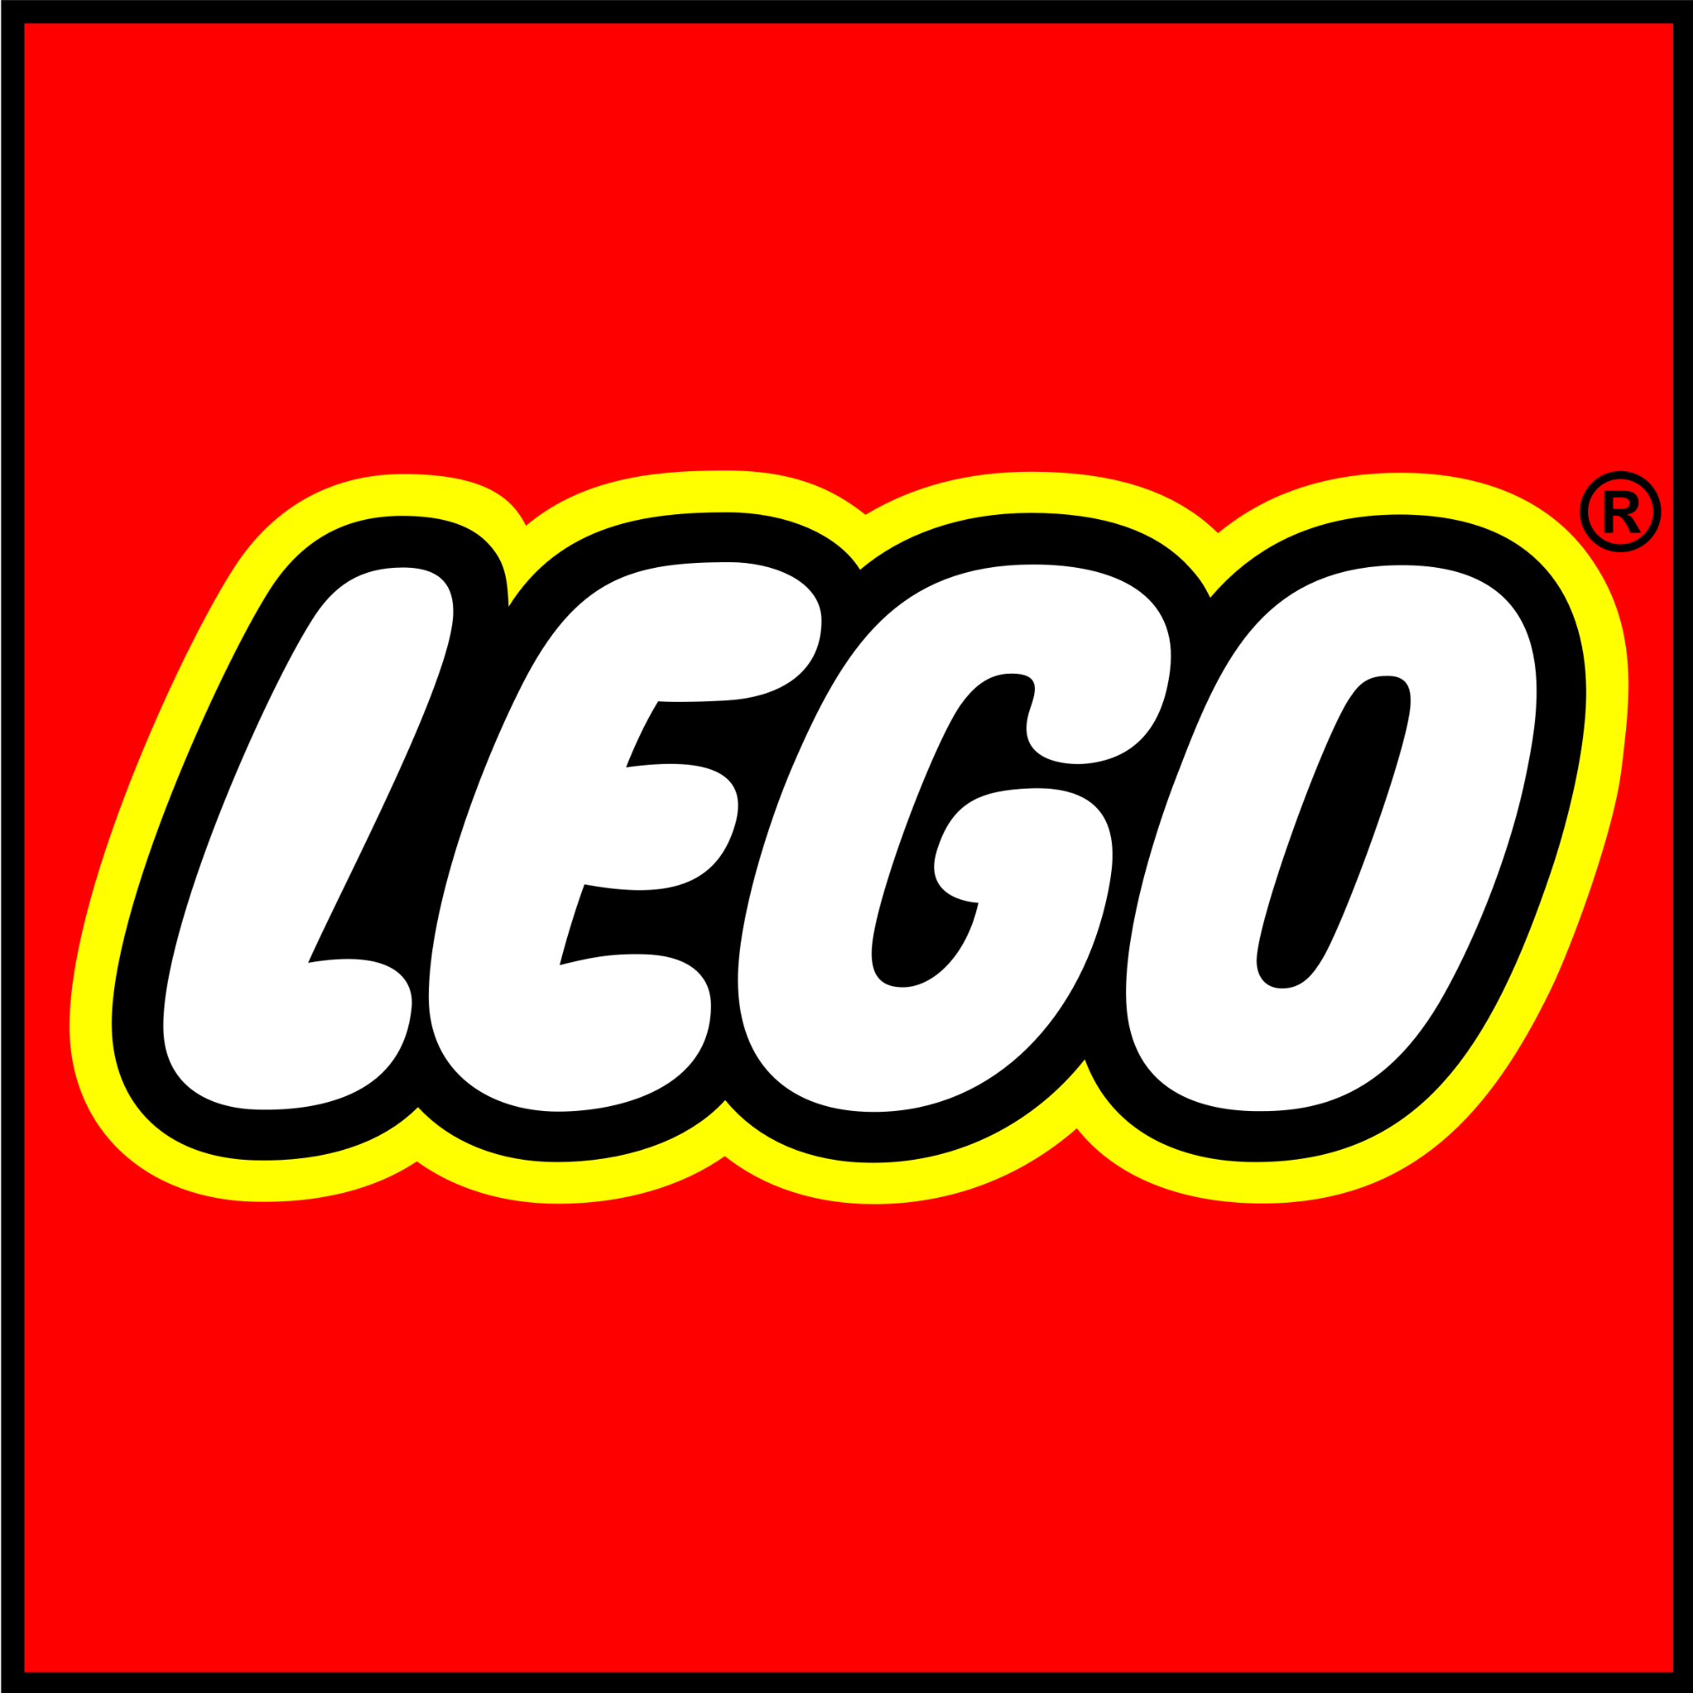

***Episode 114***

***“Mr. Sandman, Bring Me a Dream”***

September 2021

**Overview**

The purpose of this report is to identify opportunities for content creators to diversify character representations. This report measures representations of six identities in the script *Episode 114* for LEGO Titan:

* Gender
* Race/Ethnicity
* LGBTQIA+
* Disability
* Age (50+)

**Methodology**

Spellcheck for Bias is a collaboration between the Institute and the University of Southern California’s Signal Analysis and Interpretation Laboratory (SAIL) which analyzes scripts and manuscripts to create a breakdown of characters and dialogue. Spellcheck for Bias also incorporates Human Expert Coding to determine the representation of six identities (gender, race, LGBTQIA+, Disabilities, Age 50+ and Body Size). Spellcheck for Bias also provides an analysis of Tropes and Stereotypes and attributes such as racial and gender injustice, violence, and discrimination.

For this report, we analyze characters who spoke 1 line of text or more. In *Episode 114*, 14 characters met this criterion:

| **CHARACTER NAME** | **LINE COUNT** |
| --- | --- |
| MATEO | 38 |
| IZZIE | 26 |
| OLD BLIND LADY | 25 |
| MR OZ | 24 |
| ZOEY | 23 |
| SANDMAN | 21 |
| LOGAN | 19 |
| ALBERT | 17 |
| NIGHT HUNTER | 14 |
| NIGHTMARE KING | 8 |
| COOPER | 7 |
| COACH JEFFREYS | 3 |
| MS PUTNAM | 1 |
| SUSAN | 1 |

**Gender Analysis**

***For comparison, women constitute 51% of the U.S. population.***

* 36% of characters are specified as female.
* The leading character is male (“Mateo”).
* The script contains 0 character opportunities to increase gender diversity.

Characters by Gender

| **FEMALE CHARACTER** | **MALE CHARACTER** | **GENDER UNSPECIFIED** |
| --- | --- | --- |
|  | MATEO |  |
| IZZIE |  |  |
| OLD BLIND LADY |  |  |
|  | MR OZ |  |
| ZOEY |  |  |
|  | SANDMAN |  |
|  | LOGAN |  |
|  | ALBERT |  |
|  | NIGHT HUNTER |  |
|  | NIGHTMARE KING |  |
|  | COOPER |  |
|  | COACH JEFFREYS |  |
| MS PUTNAM |  |  |
| SUSAN |  |  |

The See Jane Test

| **In order to pass the See Jane test, a script/manuscript must have:** | |
| --- | --- |
| **✔** | At least one prominent character (leading, co-leading, supporting character) who is a woman who; |
| **✔** | Is not depicted with gender stereotypes or tropes. |



**Race/Ethnicity Analysis**

***For comparison, people of color constitute 38% of the U.S. population.***

* 31% of characters are specified as characters of color.
* The leading character is a character of color (“Mateo”).
* The script contains 4 character opportunities to increase racial/ethnic diversity.

Characters by Race/Ethnicity

| **CHARACTER OF COLOR** | **WHITE CHARACTER** | **RACE/ETHNICITY UNSPECIFIED** |
| --- | --- | --- |
| MATEO |  |  |
| IZZIE |  |  |
|  |  | OLD BLIND LADY |
|  | MR OZ |  |
| ZOEY |  |  |
|  | SANDMAN |  |
| LOGAN |  |  |
|  |  | ALBERT* |
|  | NIGHT HUNTER |  |
|  | NIGHTMARE KING |  |
|  | COOPER |  |
|  |  | COACH JEFFREYS |
|  |  | MS PUTNAM |
|  |  | SUSAN |

*Albert is a nonhuman character and was not included in this count

The Shonda Rhimes Test

| **In order to pass the Shonda Rhimes test, a script/manuscript must have:** | |
| --- | --- |
| **✔** | At least one prominent character (leading, co-leading, supporting character) who is a character of color who; |
| **✔** | Is not depicted with race/ethnicity stereotypes or tropes. |



**LGBTQIA+ Analysis**

***For comparison, LGBTQIA+ people comprise 5.6% of the U.S. population.***

* 0 characters are specified as LGBTQIA+.
* The leading character is heterosexual (“Mateo”).
* The script contains 9 character opportunities to increase LGBTQIA+ diversity.

Characters by LGBTQIA+ Status

| **LGBTQIA+ CHARACTER** | **HETEROSEXUAL CHARACTER** | **SEXUALITY UNSPECIFIED** |
| --- | --- | --- |
|  | MATEO |  |
|  |  | IZZIE |
|  |  | OLD BLIND LADY |
|  | MR OZ |  |
|  | ZOEY |  |
|  |  | SANDMAN |
|  | LOGAN |  |
|  |  | ALBERT |
|  |  | NIGHT HUNTER |
|  |  | NIGHTMARE KING |
|  |  | COOPER |
|  |  | COACH JEFFREYS |
|  | MS PUTNAM |  |
|  |  | SUSAN |

The Vito-Russo Test

| **In order to pass the Vito-Russo test, a script/manuscript must:** | |
| --- | --- |
| **✘** | Contain a character that is identifiably lesbian, gay, bisexual, transgender, and/or queer. |
|  | That character must not be solely or predominantly defined by their sexual orientation or gender identity (i.e. they are comprised of the same sort of unique character traits commonly used to differentiate straight/non-transgender characters from one another). |
|  | The LGBTQIA+ character must be tied into the plot in such a way that their removal would have a significant effect, meaning they are not there to simply provide colorful commentary, paint urban authenticity, or (perhaps most commonly) set up a punchline. |



**Disability Analysis**

***For comparison, people with disabilities constitute 19% of the U.S. population.***

* 7% of characters are specified as having a physical, cognitive, or communication disability.
* The leading character is not specified as having a disability (“Mateo”).
* The script contains 13 character opportunities to increase disability diversity.

Characters by Disability Status

| **CHARACTER WITH DISABILITY** | **CHARACTER WITHOUT DISABILITY** | **DISABILITY STATUS UNSPECIFIED** |
| --- | --- | --- |
|  |  | MATEO |
|  |  | IZZIE |
| OLD BLIND LADY |  |  |
|  |  | MR OZ |
|  |  | ZOEY |
|  |  | SANDMAN |
|  |  | LOGAN |
|  |  | ALBERT |
|  |  | NIGHT HUNTER |
|  |  | NIGHTMARE KING |
|  |  | COOPER |
|  |  | COACH JEFFREYS |
|  |  | MS PUTNAM |
|  |  | SUSAN |

The Marlee Matlin Test

| **In order to pass the Marlee Matlin test, a script/manuscript must have:** | |
| --- | --- |
| **✔** | At least one prominent character (leading, co-leading, supporting character) with a physical, cognitive, or communication disability who; |
| **✘** | Is not depicted with disability stereotypes or tropes. |



**Age (50+) Analysis**

***For comparison, people ages 50+ constitute 34% of the U.S. population.***

* 36% characters are specified as ages 50+.
* The leading character is under 50 (“Mateo”).
* The script contains 4 character opportunities to increase age diversity.

Characters by Age

| **CHARACTER 50+** | **CHARACTER UNDER 50** | **AGE UNSPECIFIED** |
| --- | --- | --- |
| v | MATEO | LOGAN |
| MR OZ | IZZIE | MR OZ |
| OLD BLIND LADY |  | MATEO |
| MR OZ |  |  |
|  | ZOEY |  |
| SANDMAN |  |  |
|  | LOGAN |  |
| ALBERT |  |  |
|  |  | NIGHT HUNTER |
| NIGHTMARE KING |  |  |
|  | COOPER |  |
|  |  | COACH JEFFREYS |
|  |  | MS PUTNAM |
|  |  | SUSAN |

The Betty White Test

| **In order to pass the Betty White test, a script/manuscript must have:** | |
| --- | --- |
| **✔** | At least one prominent character (leading, co-leading, supporting character) who is 50+ who; |
| **✔** | Is not depicted with age stereotypes or tropes. |



**Body Size Analysis**

* N/A
* We do not analyze body size for this script.

| **CHARACTER WITH LARGE BODY TYPE** | **CHARACTER WITH SMALL/MEDIUM BODY TYPE** | **BODY SIZE UNSPECIFIED** |
| --- | --- | --- |
|  |  |  |
|  |  |  |
|  |  |  |
|  |  |  |
|  |  |  |
|  |  |  |
|  |  |  |
|  |  |  |
|  |  |  |
|  |  |  |

The Lizzo Test

| **In order to pass the Lizzo test, a script/manuscript must have:** | |
| --- | --- |
|  | At least one prominent character (leading, co-leading, supporting character) with a large body type who; |
|  | Is not depicted with size stereotypes or tropes. |

**Intersectional Analysis**

|  | **Female Character** | **Character of Color** | **LGBTQIA+ Character** | **Character with a Disability** | **Character 50+** |
| --- | --- | --- | --- | --- | --- |
| **Female Character** |  | **YES** | **NO** | **YES** | **YES** |
| **Character of Color** | **YES** |  | **NO** | **YES** | **YES** |
| **LGBTQIA+ Character** | **NO** | **NO** |  | **NO** | **NO** |
| **Character with a Disability** | **YES** | **YES** | **NO** |  | **YES** |
| **Character 50+** | **YES** | **YES** | **NO** | **YES** |  |

**Positive Aspects and Continued Positive Representation:**

* Positive Evolution of Masculinity:
  + Logan’s character has become increasingly complex this season, written with a subtle arc which actively challenges his initial hypermasculinity in the season’s early episodes. Once a stereotypical “jock” and “bully”, he is written to have expanded interests in music (auditioning as a DJ), comedic moments (unafraid of being silly when listening to his EDM music), and even grabs Izzie’s hand out of fear in this episode.
* Highlights Soft Skills and Extended Non-Violent Action Sequences:
  + This episode highlights soft skills (non-physical, non-violent) and features non-violent action sequences. Oz deciphers a musical clue (pp. 4), nostalgia is used by the witch to lure in her victims, and Logan’s music is used to overcome the Sirens.
* Features Inclusive Language:
  + Albert uses “y’all” to refer to a mixed gender group instead of the gendered “you guys” (pp. 5).

**Potential Pitfalls**

* **Potential Ableism and Sexism:**
  + Part of the witch’s disconcerting effect on people is her blindness. Making a disability into a disturbing image can create an association between disability, evil, and fear for viewers.
  + The blind witch embodies additional stereotypes, such as:
    - VILLAIN: Associating ‘evil’ with a disability is considered a harmful stereotype. Several films have come under scrutiny for depicting evil characters as disabled[1].
    - ALONE: The witch, a blind female character over 50, is ALONE, a stereotype associated with persons with disabilities and women over 50. This stereotype suggests women over 50 that are disabled are unworthy of love.
    - ANONYMITY: The witch is referred to as “old blind lady” and “witch” in the script. Given her marginalized status as a disabled woman over 50, consider giving her a name and humanizing qualities in the script.
* **Potential Anti-Semitism**:
  + The Sandman, who is coded as a Jewish character (uses the phrases “Oy Vey” and “bubbalah”, pp. 25), is written with some Jewish stereotypes:
    - Wearing a “jeweler’s eyepiece.”
    - Transactional: “that’ll cost ya..everything has a cost” (pp. 25).
    - Greedy: Wealthy in dreams, however desires more dreams.
      * Takes Zoey’s most precious dream out of greed (pp. 25).

1. <https://www.nytimes.com/2020/11/17/movies/witches-movie-disability.html>